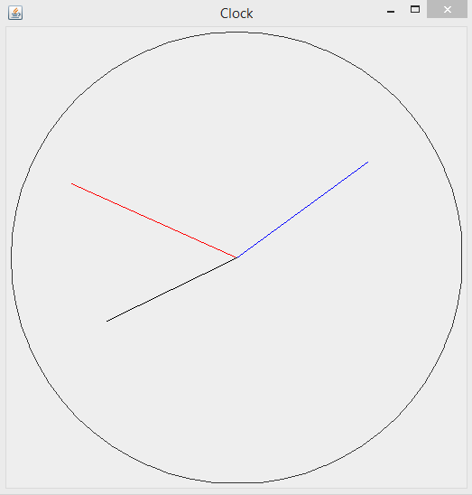Clock displaying 8:09PM.

Black: Hours

Blue: Minutes

Red: Seconds

Output from the dumpArray() method.

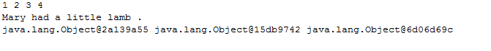

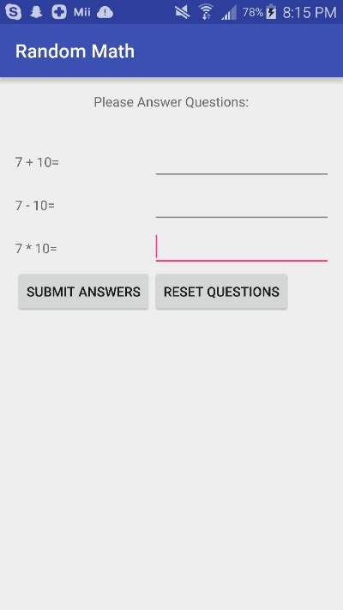Android App Output:

